2020
«NameLine1» «RegionBrigade» «StationCode»
«OtherName»
«Address1»
«Address2»
«Address3»
«Address4»
«Address5»
«Address6»

Circular: 2021HOC0462MW

9 September 2021

To: All Members

Dear Brother / Sister

20 Years Since 9/11 Attacks

All FBU members will wish to remember and commemorate the horrific events of 11 September 2001 which saw the attacks on the World Trade Centre twin towers and elsewhere. Almost 3,000 people lost their lives, including 343 firefighters. I have written to Brother Edward Kelly, General President of the International Association of Firefighters (IAFF) our sister union in the USA and Canada. The letter is attached.

The IAFF faced huge challenges in tackling the immediate and long-term impact of 9/11 on IAFF members and their families. It is to the great credit of the IAFF that they were able to respond immediately and over the subsequent years in supporting those affected in so many ways. As you will be aware, the impact has extended beyond those immediately killed, with long term effects on the health of many of those who attended or otherwise affected by the events of that day. Many FBU members in the UK, as with firefighters across the world, have been keen to support our colleagues in as many ways as possible. There have been long lasting bonds and friendships built as a result. The FBU and the IAFF have a close working relationship, including regular discussions of the challenges facing our profession across the globe.

I am sure FBU members will wish to mark the twentieth anniversary and therefore recommend that on-duty crews mark a minute’s silence on Saturday 11 September at 13:46, in the manner in which we have marked Firefighters’’ Memorial Day in recent years.

Yours In Unity
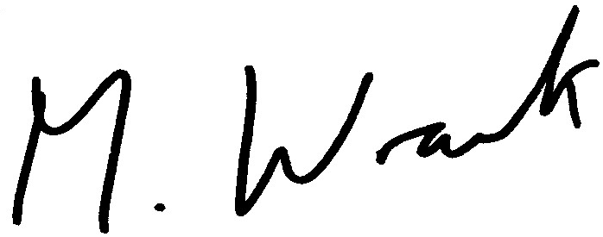

Matt Wrack
General Secretary

Attach.

MW/jh

