Circular: 2019HOC0639MW

«NameLine1» «RegionBrigade» «StationCode»
«OtherName»
«Address1»
«Address2»
«Address3»
«Address4»
«Address6»

9 December 2019

TO: ALL MEMBERS

Dear Brother / Sister

The departure of the London Fire Brigade Commissioner: firefighters are being scapegoated

The announcement that the Commissioner of the London Fire Brigade, Dany Cotton, is to leave the service early (31 December) has shocked and angered many FBU members.

As a result of this announcement, I have made contact with the mayor of London’s team and an urgent meeting is being arranged. I will explain the anger of FBU members regarding this matter. I have spoken to the Deputy Mayor for Fire & Resilience and set out the areas of concern of the FBU regarding this issue.

It is unusual for the union to comment on the departure of a Commissioner (or a Chief Fire Officer) who is not a member of the FBU. However, in this case it is clear that there are wider implications regarding the public debate about the fire at Grenfell Tower and the response of firefighters and the fire and rescue service. There is an attempt, in some quarters of the media and among some politicians, to create a narrative around the idea of a ‘failing public service.’ This is not being done in order to deliver the improvements needed in our service but in order to divert attention from the real failings in public policy and the real failings of politicians in central government. The FBU has long argued for significant improvement in our service but this requires major political change in relation to fire service policy. The timing of the LFB Commissioner’s departure seems to be more a matter of political convenience and point-scoring between politicians in relation to elections than it does about new concerns about the LFB’s performance.

The announcement of Dany Cotton’s departure follows fast on the unjust and unfair criticism made of individual firefighters and control staff in the Phase 1 report of the Grenfell Tower Inquiry (GTI). The GTI report also reached damaging conclusions regarding the issue of ‘Stay Put’; conclusions based on assertion rather than evidence, as we have set out in earlier circulars. The GTI report fails to put the fire into context, namely deregulation by central government and the total building failure due to decisions of the owners/managers. The report fails to put the LFB response into the context of fire and rescue service management as a whole across the UK. The GTI also appears to have ignored its own experts and advisers and it even failed to require the advice of its own expert witness on firefighting matters. The inquiry’s judgments have been made with hindsight and fail to appreciate the real uncertainties and difficulties firefighters at all levels faced on the night.

/Cont…..

2.

Each of these developments will strengthen the concerns and scepticism of FBU members regarding the inquiry process. We were promised after 14 June 2017 that this terrible event would be a major turning point for public safety and for fire policy. Instead of this, it is increasingly evident that the aim is not to get to the real causes of the tragedy at Grenfell but rather to do everything possible to distract attention from those really at fault; those responsible for the dangerous refurbishment of the building; for the development and selling of dangerous construction products; or those responsible for de-regulating and fragmenting the public safety regime – including in the fire and rescue service.

It is now almost 2 ½ years since the Grenfell Tower fire, yet little or nothing has happened to address what happened that night. Among other things;

- There are still large numbers of buildings with ACM cladding;
- There are other forms of flammable cladding which pose risks to residents and to firefighters, but which are not being addressed;
- Several major fires this year have further highlighted failures in compartmentation, whether these failures were related to cladding or not;
- Nobody has been held responsible for the refurbishment of Grenfell Tower, which undermined every element of fire protection in the building;
- No government ministers (past or present) have been held to account over the ignoring of previous warnings or recommendations;
- No government ministers (past or present) have been held to account for the dismantling of the safety regime covering buildings;
- Indeed, certain former ministers with key roles in relation to housing and fire policy have been given peerages - the contrast with the treatment of firefighters could not be sharper;
- The public still face a post code lottery across the UK in relation to the emergency response to fires and other emergencies;
- Far from ending, the cuts to the fire and rescue service have continued and are continuing.
In these circumstances, where the approach of government is characterised by complacency and blame-dodging, the attention purely on the response of the LFB, including on the role of the LFB Commissioner is unfair and unjust.

The GTI report itself identifies that failings within the fire and rescue service were ‘systemic’. That ‘system’ originates ultimately in the relevant legislation and in central government policy, yet these crucial issues remain ignored. The decisions which created the broken fire safety regime were made by politicians at government level. We will neither forget this nor allow those responsible to avoid scrutiny and challenge.

Best wishes.

Yours fraternally
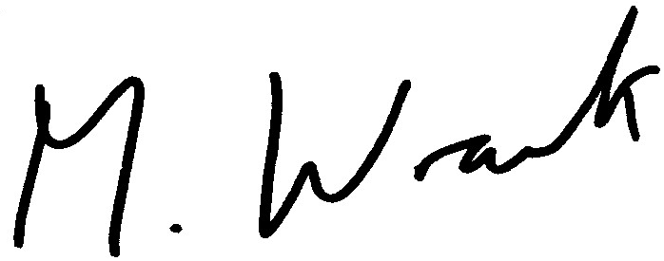

MATT WRACK
General Secretary

MW/jh

