2020
«NameLine1» «RegionBrigade» «StationCode»
«OtherName»
«Address1»
«Address2»
«Address3»
«Address4»
«Address5»
«Address6»

Circular: 2022HOC0027MW

20 January 2022

To: All Members

Dear Brother/Sister

Grenfell Tower Inquiry – January 2022 update

The Grenfell Tower Inquiry (GTI) hearings have been adjourned over the Christmas period, but are scheduled to resume on 24 January 2022 with closing statements for Module 5 and Module 6 (firefighting). Module 6 evidential hearings will resume the following week on 31 January.
During the week beginning 24 January 2022, the FBU and other core participants will have the opportunity to provide a closing statement to the Inquiry that assesses the evidence heard during Modules 5 and the first part of Module 6.
Our statement will be heard at 14:30 on Monday 24 January 2022 and can be accessed live from the GTI website https://www.grenfelltowerinquiry.org.uk/.
We strongly encourage members to tune in and listen to our statement, which will highlight the ways in which the LFB and FRSs more generally, have been damaged by years of austerity, deregulation and privatisation. We have also prepared a more detailed written submission which will be available on the GTI website after our oral statement has been heard (and we will circulate it when it is publically available).
Representatives of the Bereaved, Survivors and Residents, the London Fire Commissioner, the Mayor of London will also be giving evidence on the day (timetable below).
Looking ahead
The remainder of Module 6 focuses on the testing and certification regime and the government’s oversight of the building industry and fire safety. A number of current and former government ministers are due to give evidence, including Eric Pickles, the former secretary of state for communities, Brandon Lewis, the current Northern Ireland secretary, and the former housing minister Gavin Barwell (see “Grenfell inquiry: ex-ministers and serving secretary of state to be cross-examined”, The Guardian, 4th Jan 2022). These and other political leaders have many serious questions to answer about what they knew of the dangers of flammable cladding, how widespread its use was and their role in promoting business interests above health and safety. Again, we strongly encourage members to tune in and we will share the timetable with you as soon as it is made public.

Contd/2…

-2-

Hearings are scheduled to continue until at least May 2022, with Modules 4 (Aftermath) and 7 (Experts) to be heard following Module 6. The Inquiry will conclude with Module 8 that will examine findings relating to the deceased. A date for this module has yet to be announced.

Yours in unity

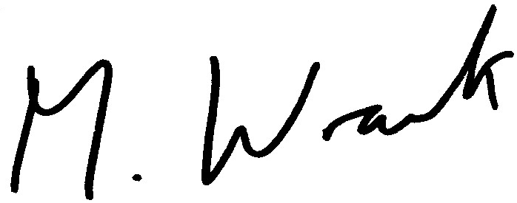

Matt Wrack
General Secretary

Att.

MW/sll

TIMETABLE MODULE 5 & 6 (firefighting) CLOSINGS - 24 January 2022
Monday 24 January 2022

Bereaved, Survivors & Residents - Team 1 Danny Friedman QC 10:00 – 11:00
(in person)

Morning Break

Bereaved, Survivors & Residents - Team 2 Leslie Thomas QC 11:15 – 12:15
(in person)

Lunch

Mayor of London (in person) Anne Studd QC 14:00 – 14:30

Fire Brigades Union (in person) Martin Seaward 14:30 - 15:30

Break

London Fire Commissioner (in person) Stephen Walsh QC 15:45 – 16:45

