“Bring Avon fire service back from brink”: firefighters call for reversal to cuts after damning report
November 23, 2023

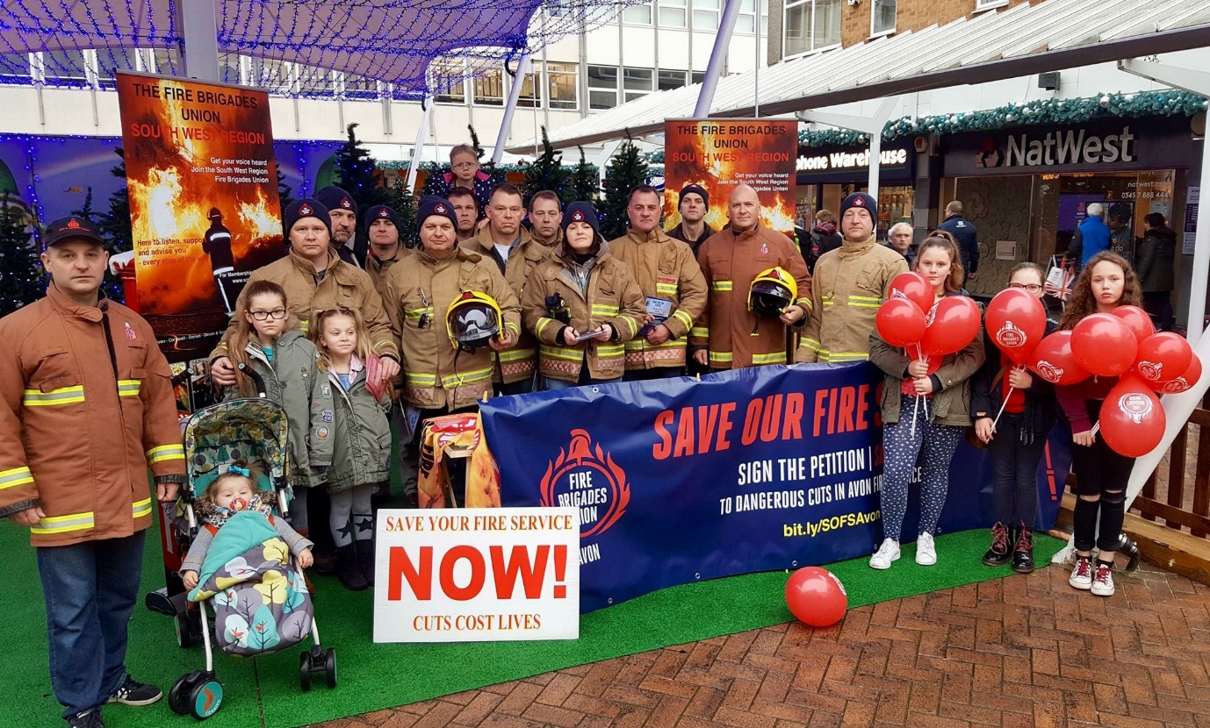
The Fire Brigades Union has responded to the latest inspection report into Avon Fire and Rescue Service.
Released yesterday, the report by Her Majesty's Inspectorate of Constabulary and Fire & Rescue Services (HMICFRS) finds Avon fire service “inadequate” at responding to fires and other emergencies.
Matt Wrack, FBU general secretary said:
“This alarming report paints a picture of a dysfunctional and mismanaged fire service. Deep cuts to resources have left Avon fire and rescue in a state of crisis. It is shocking that a modern fire service has been rated “inadequate” at responding to and preventing fires, and the reports findings on discriminatory conduct in the service is equally concerning.
Firefighters work incredibly hard under difficult circumstances to keep their communities safe. Avon fire authority’s latest decision to axe 40 firefighter posts threatens to push an overstretched service beyond breaking point. The FBU stands with our members and the public in the fight against these dangerous cuts.”

Dave Roberts, FBU South West regional secretary said:

This damning inspectorate report into Avon Fire and Rescue Service exposes a service in a state of crisis. The service has been rated inadequate at preventing and responding to fires. Response times are slower than the national average. This is an emergency.
We have lost 1 in 5 firefighters since 2010 across the UK, and in October Avon's fire authority announced that we will lose 40 more to brutal cuts. This austerity is leaving our service severely under-resourced, putting homes and lives at risk.
The service is fundamentally lacking a crucial response strategy outlining how it will respond to a range of emergencies. This is despite the inspectorate raising an accelerated cause for concern in August stating that failure to collect information on risk is threatening public and firefighter safety.
The report also points to an unacceptable culture where firefighters are unable to raise or challenge inappropriate and discriminatory behaviour. Senior leaders must start taking this seriously.
The people of Avon deserve a fire service equipped to keep communities safe. Instead, our firefighters are working in extremely difficult conditions without enough resources or support.
To bring our service back from the brink, we need urgent investment and leadership. Avon fire authority must reverse the decision to cut 40 firefighters from our region as the first step.”

WE SAY NO
WE SAY DEFEND OUR FIRE SERVICE

WE SAY AVON! STOP THE CUTS

