Our Ref: MW/jh

Letter sent by email

Edward A. Kelly – General President
International Association of Fire Fighters
1750 New York Avenue
NW Washington
DC 20006

9 September 2021

Dear Brother Kelly

Re. Solidarity with Firefighters of New York on 20th anniversary of September 11 attacks

I write on behalf of the Fire Brigades Union to express our solidarity on the 20th anniversary of the September 11 attacks, and with the IAFF in its ongoing work to represent and fight for all those affected by those terrible events. We are sorry not to be with you in person, but FBU members will be marking the anniversary in various ways, including at fire stations across the UK.

The FBU commemorates the loss of 343 firefighters and the 207 IAFF brothers and sisters lost to 9/11-related illnesses. We must always remember those people who went to work that day and never came back and those who have suffered the long-term consequences of that catastrophic event.

Our members will pause and reflect on this anniversary and pay honour to those that helped save lives and protect us all. Firefighters across the UK stand shoulder to shoulder with you and pay tribute.

Our thoughts are always with the families, friends and colleagues affected by that horrendous day.

Yours in unity,
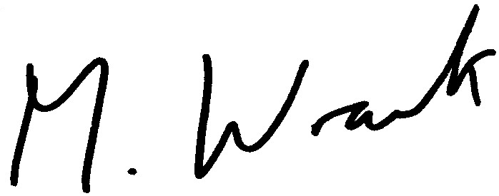

Matt Wrack
General Secretary

